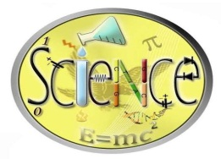

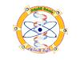
ICBSEA
2016

International Conference on Basic Science and Environmental
Applications (ICBSEA) - April 3 – 4, 2016, Fayoum, Egypt

Registration Form

Name:

Nationality:

Qualification:

Field of Specialization:

Designation:

Institution / University:

Full Address:

Passport No.:

Phone No.:

Fax:

E-mail:

Participation (Oral/Poster):

Paper Title:

Abstract:

